DevOps Code RealTime

Quick Start Guide
Table of Contents
1 Overview 3
2 Download 4
2.1 IDE/Tool 4
2.1.1 Java 4
3 Install 5
4 Post-Installation Configuration 6
4.1 Setup Java 6
4.2 Setup C++ Build Tools 7
5 Uninstalling 8

Overview
This document helps you getting started with DevOps Code RealTime. It covers the following:
- Downloading Code RealTime and its documentation (see Download)
- Installing Code RealTime (see Install)
- Setting post-installation configuration for Code RealTime (see Post-Installation Configuration)
- Uninstalling Code RealTime (see Uninstalling)

Download
The Code RealTime product and documentation can be downloaded from the Visual Studio Marketplace and Open VSX Registry.
The Code RealTime detailed product documentation is available at https://secure-dev-ops.github.io/code-realtime/.
To download the commercial versions of Code RealTime, please refer to the following sources:
- My HCLSoftware portal: https://my.hcl-software.com/downloads/devops/codert
- IBM Passport Advantage: https://www.ibm.com/software/passportadvantage/

IDE/Tool
Code RealTime can be used with either Visual Studio Code or Eclipse Theia.
- Download Visual Studio Code.
- Download Theia IDE.
An extension for C/C++ development should be installed for Code RealTime to work. These are supported by Code RealTime:
- C/C++ for Visual Studio Code available for Visual Studio Code
- Clangd available for Visual Studio Code and Eclipse Theia

Java
The Code RealTime language server requires a Java Virtual Machine (JVM). It should be a JVM for Java 21 or later.
You can use the OpenJDK which is a free JDK from https://www.openlogic.com/openjdk-downloads.

Install
Note: The Code Realtime documentation provides in detail how to install the product. You can refer to the Installing topic of Code RealTime documentation. This covers information related to installing Code RealTime from VSIX, installing Code RealTime from Docker Image, viewing Code RealTime installation information and portable code RealTime Mode installation.

Post-Installation Configuration
After a successful installation you need to perform a few configuration steps before you can start to use Code RealTime.

Setup Java
Code RealTime uses a Java language server and hence needs a Java Virtual Machine (JVM). It's required to use a JVM for Java 21 or newer. If an appropriate JVM cannot be found when the Code RealTime extension is activated (which for example happens the first time you open an Art file), you will receive an error message.
Code RealTime follows the steps below in priority order when it looks for an appropriate JVM to use:
1. The setting code-rt.languageServer.jvm is examined. If it specifies a path to a JVM it will be used. You can edit this setting by invoking File - Preferences – Settings and then type the setting id mentioned above in the filter box.
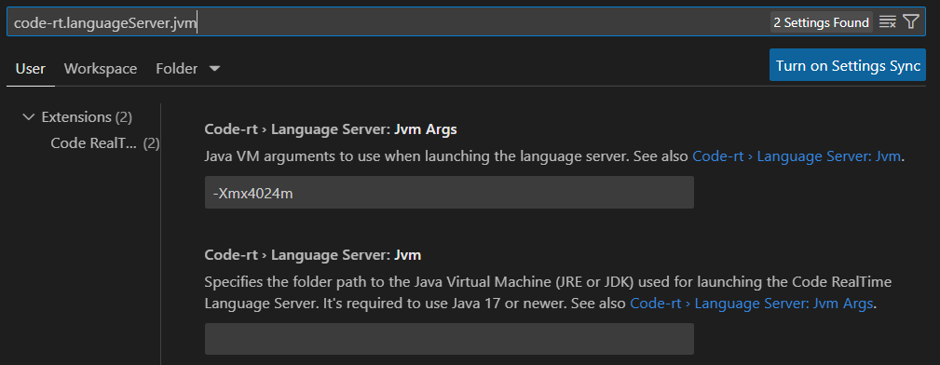
2. The environment variable JAVA_HOME is examined. If it specifies a path to a JVM it will be used.
3. An attempt is made to launch the java command without using a path. The first JVM found in the system path, if any, will be used.
You may also need to adjust the arguments for the JVM. By default the JVM is launched with the below argument:
-Xmx4024m
To change the JVM arguments set the setting code-rt.languageServer.jvmArgs shown in the image above.

When the Code RealTime extension is activated information about which Java that is used is printed to the Art Server output channel.
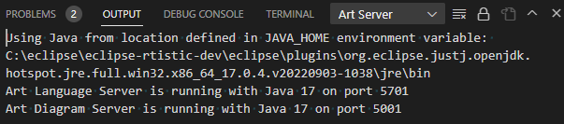
Here you will also see if the launching of the language server for some reason failed.

Setup C++ Build Tools
When Code RealTime builds generated C++ code it uses C++ build tools such as a make tool, a C++ compiler, a C++ linker etc. These tools need to be in the path when you start Visual Studio Code or Eclipse Theia. If you have multiple C++ build tools installed, make sure the correct ones are present in the path before launching Visual Studio Code or Eclipse Theia. For example, if you use the Microsoft C++ compiler, it's recommended to launch from a Visual Studio native tools command prompt with the correct version (e.g. 32 bit or 64 bit). Build errors caused by inconsistent versions of C++ build tools being used can be tricky to find.

You also need to install an extension for C/C++ development into Visual Studio Code or Eclipse Theia. Even if you can use any such extension, Code RealTime provides the best integration with either C/C++ for Visual Studio Code or clangd.

Uninstalling
To uninstall Code RealTime follow these steps:

1. Click "Extensions" in the left side-bar.



2. Find the Code RealTime extension in the "Installed" section and invoke the "Uninstall" command (in Visual Studio Code the command is available in the context menu, while in Theia it shows up as a button to click).

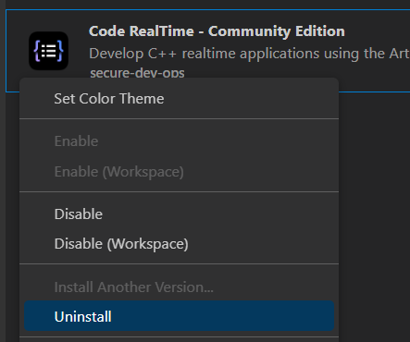

Once the uninstallation is finished you will no longer see Code RealTime in the "Installed" section.

